Observational study of the effects of upper respiratory tract infection on hydration status.

Eccles R, Mallefet P.
Multidiscip Respir Med. 2019 Oct 31;14:36. doi: 10.1186/s40248-019-0200-9. eCollection 2019.
PMID: 31695912
Abstract
Background: A frequent treatment recommendation during acute respiratory infection is to increase fluid intake. This is the first study to investigate whether upper respiratory tract infections (URTIs) such as common cold can lead to dehydration, as commonly believed by the public.
Methods: This was an exploratory, noninterventional, observational, single-center study. Subjects made 2 visits to a UK study center for assessments of dehydration, once during URTI and then 2–3 weeks later when fully recovered. The primary endpoint was a comparison of serum osmolality during vs after URTI. Complete blood count, serum urea, serum electrolytes, urine parameters (eg, osmolality, specific gravity, color), body weight/BMI, subjective assessment of thirst, and physician assessment of dehydration were additional outcomes. Only descriptive statistics and shift tables were used.
Results: Fifty-five otherwise healthy adults with moderate to severe URTI of < 120 h in duration were enrolled (63.6% female, 94.5% white, mean [SD] age 21.0 [6.8] years). There was no evidence of dehydration based on serum osmolality (mean [SD] 287.63 [4.83] mosm/kg during URTI; 288.60 [5.99] mosm/kg after recovery). With only a few exceptions, complete blood count, serum urea, serum electrolytes, urine specific gravity, urine color, and physician ratings of hydration remained stable. Body weight decreased > 1% in 34.0% of subjects and increased > 1% in 17.0% between visits, with similar changes in BMI. Urine osmolality varied: 14 subjects showed a decrease and 5 showed an increase, resulting in a higher mean [SD] urine osmolality during URTI (700.50 [231.59] vs 618.47 [320.29] mosm/kg). Subjects perceived greater thirst during URTI.
Conclusions: In this pilot observational study, we found no evidence that URTIs such as common cold are associated with dehydration, contrary to popular belief.

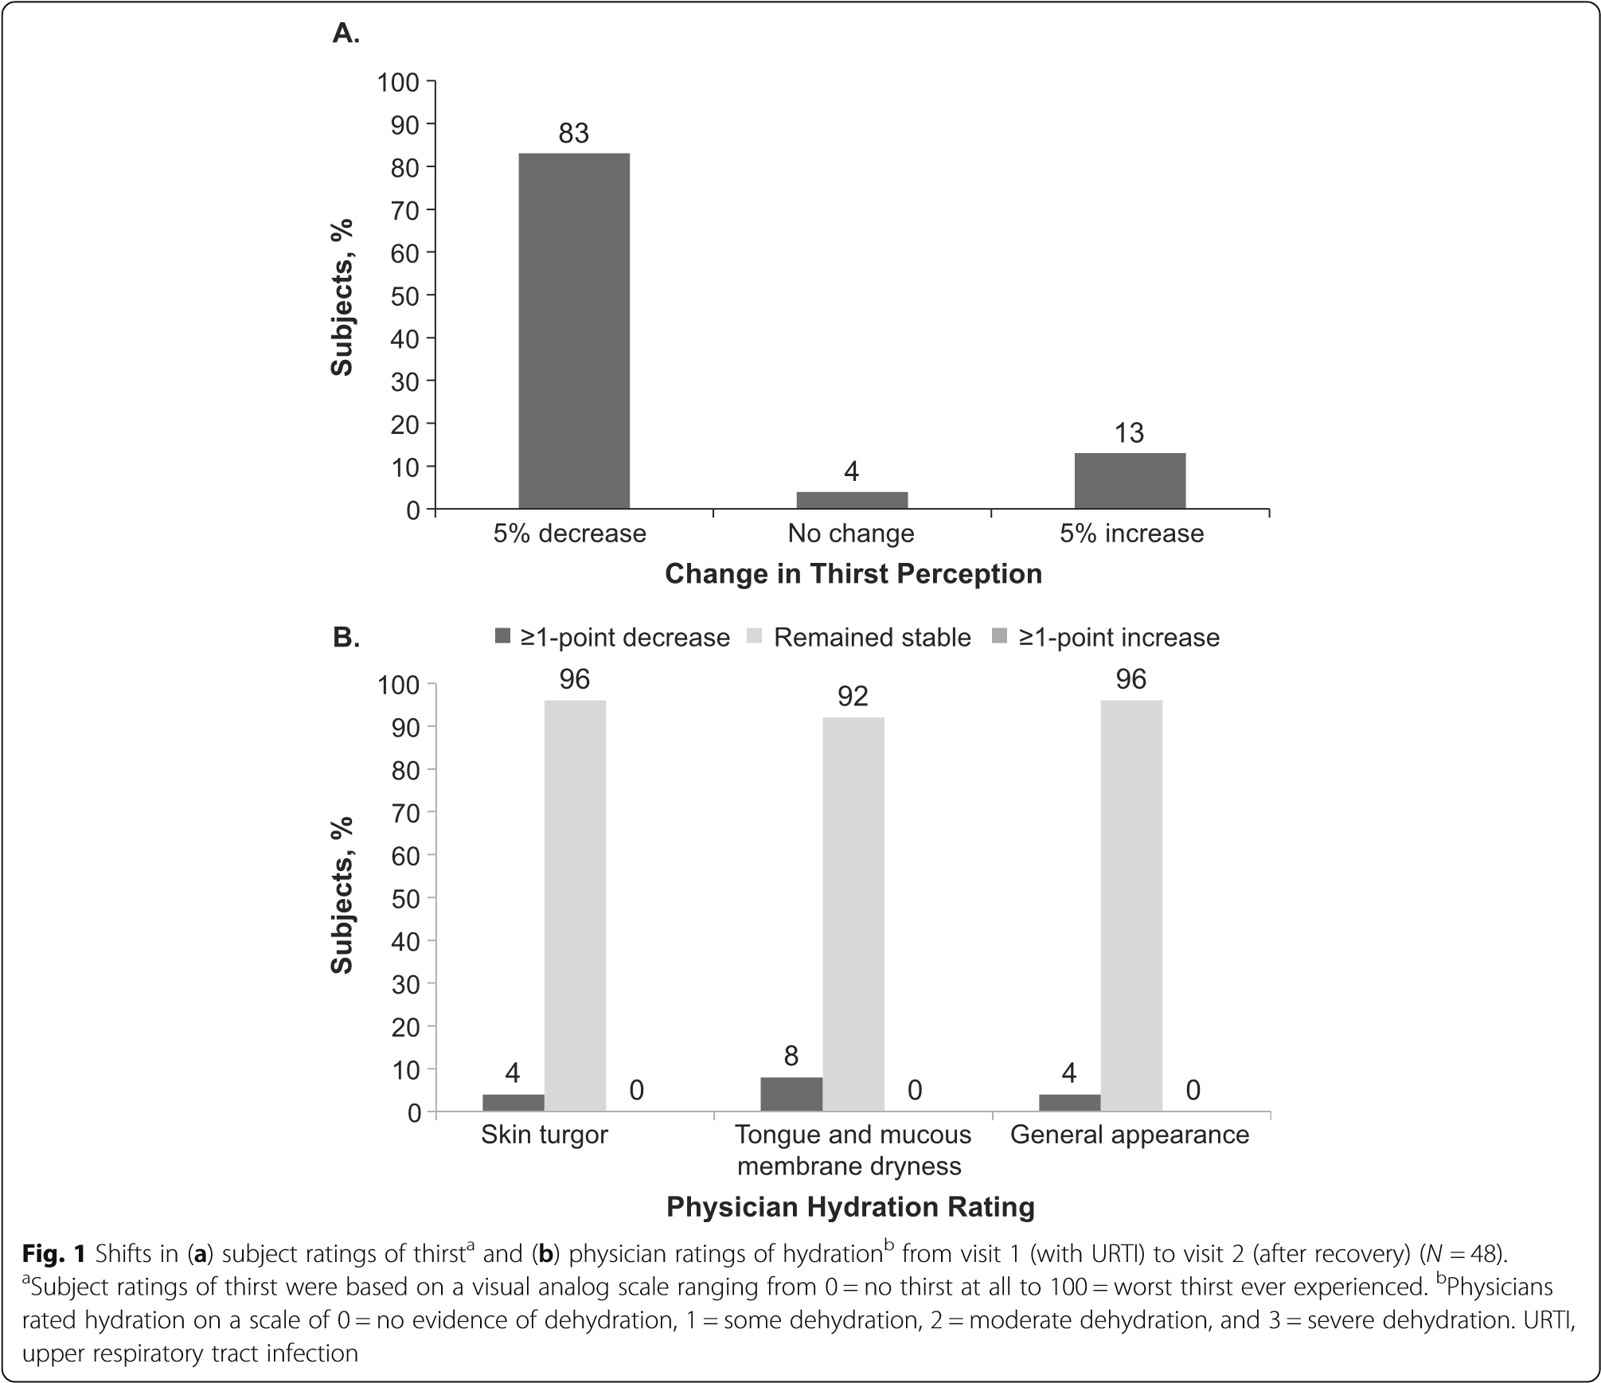

It is believed that upper respiratory tract infections (URTIs) such as common cold can lead to dehydration. Although there are no solid clinical data to support the view, it is generally recommended that persons suffering from the common cold should stay hydrated in U.S.A. Dehydration can lead to serious medical problems, but there is no single “gold standard” method to use, accurate, precise, rapid, and comprehensive for assessing dehydration. It is the first pilot study to investigate whether there is evidence of dehydration during a self-diagnosed URTI such as common cold. In this study, dehydration was identified by comparing serum and urine osmolality of patients with moderate to severe URTIs with that in the same patients after recovery. It provides a good guide on clinical interventions of URTIs and clinical assessment of dehydration in URTIs.

