Centers Urgent Care is my last clinical rotation. I enjoy this rotation due to its friendly working environment, and since my future practice might focus on primary care and urgent care, I benefit from this rotation greatly.
My working schedule in the Centers Urgent Care is from 9:00 am to 9:00 pm, usually three days a week, but sometimes five days a week. In the clinic, there are physician assistants, nurses, medicine assistants and a manager. I followed the physician assistant. When a patient came, a nurse checked the vital signs, got the brief H&P, and sometimes performed the necessary lab tests such as rapid strep test and flu test. Then I would come to the room, introduce myself, ask for H&P, perform the physical exam, and write down the notes. I would report all the information to the physician assistant, and also tell him the possible diagnosis, differential diagnoses and treatment options. Then the physician assistant would come to check the patient himself and tell me the results. I also did some procedures, such as laceration suture and removal, splinting, vaccine injection, and EKG.
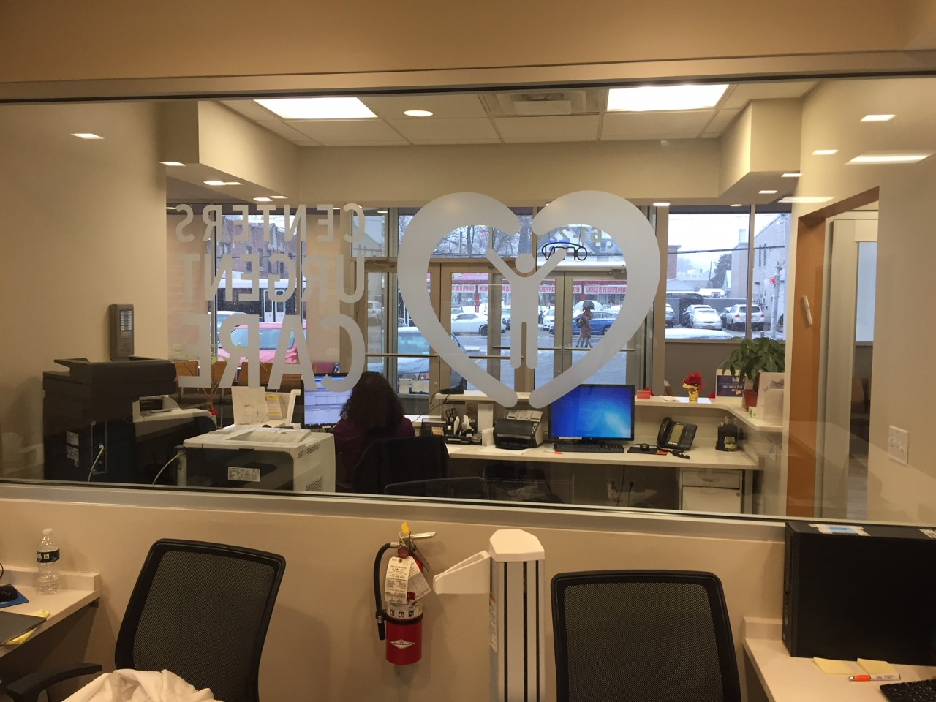
In this rotation, I met with patients with various conditions and problems, although most patients came due to the upper respiratory infection, urinary tract infection, gastroenteritis, or minor lacerations. Firstly, I had chances to refresh my knowledges to determine if the patients have left-threatening conditions that need to go to ER or we can just discharge after management. For example, a patient with chest discomfort was suspected as inferior myocardial infarction and was sent to ER, although the symptoms were minor and EKG was atypical. Secondly, I had chances to learn and practice my clinical skills, such as sutures in different types of lacerations. At last, I had time to talk with patients to get their whole conditions and retrieve a complete H&Ps. It is great to have time to review your practice and feel you are more and more confident that you could practice independently. I love the conditions.
In my rotation, I realized some problems. I need more practices on my language because my reactions to the patients’ descriptions are not timely sometimes. I will continue practicing on it.

