Acute gastroenteritis article summary

Infect Chemother. 2019 Jun;51(2):217-243. doi: 10.3947/ic.2019.51.2.217.
Guideline for the Antibiotic Use in Acute Gastroenteritis.
Kim YJ, Park KH, Park DA, Park J, Bang BW, Lee SS, Lee EJ, Lee HJ, Hong SK, Kim YR.
Abstract
Acute gastroenteritis is common infectious disease in community in adults. This work represents an update of 'Clinical guideline for the diagnosis and treatment of gastrointestinal infections' that was developed domestically in 2010. The recommendation of this guideline was developed regarding the following; epidemiological factors, test for diagnosis, the indications of empirical antibiotics, and modification of antibiotics after confirming pathogen. Ultimately, it is expected to decrease antibiotic misuse and prevent antibiotic resistance.
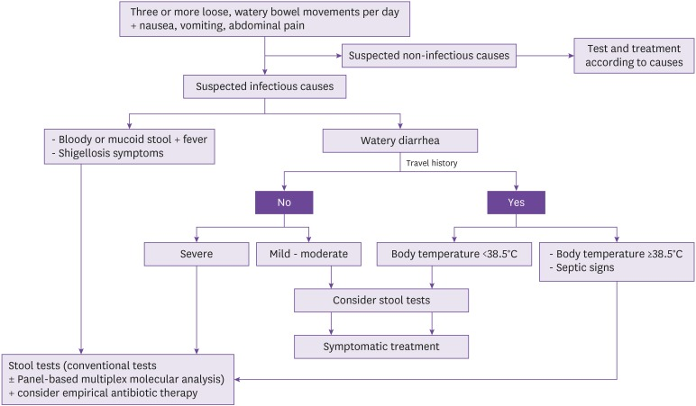
Figure 2. Algorithm for treatment of infectious diarrhea. - Mild: Diarrhea is bearable, and the patient is capable of travelling or other activities as planned. - Moderate: Diarrhea interferes planned travels or other activities. - Severe: Diarrhea interferes with daily activities and prevents planned travels or other activities.
Acute gastroenteritis is a common disease. In general, most acute gastroenteritis is caused by virus, can improve spontaneously and does not require antibiotic treatment. Inappropriate use of antibiotics may cause antibiotic-associated diarrhea or other complications and may also lead to antibiotic resistance in the long term. But sometimes antibiotic treatment can help. There is still debate about the clinical guideline for antibiotic treatment of gastrointestinal infections, so this study tried to develop the guideline in order to provide clinical recommendations based on the newest evidence on empirical antibiotic therapy for suspected acute gastroenteritis, which is commonly seen in clinic, and on targeted antibiotic treatment for cases with confirmed bacterial growth, with an ultimate aim to decrease antibiotic misuse and to prevent the rise of antibiotic-resistant bacterial strains. It has important clinical significance.

