Rego Park family medicine is my eighth clinical rotation. In this rotation, I love it because I learned to how to deal with different clinical family medicine conditions in this rotation, and since my future practice might focus on primary care, I benefit from this rotation greatly.
My working schedule in the Rego Park Clinic is usually from 9:00 am to 4:00 pm on Tuesdays and Fridays, and from 9:00 am to 7:00 pm on Mondays and Thursdays. I worked in different units. In the clinic, there are a physician, a nurse, and a medicine assistant. I followed the physician. When a patient came, I checked the vital signs, got the H&P, ordered the necessary lab tests, and wrote down the notes. Then the physician would come to check the patient again with me. I also did some procedures, such as blood drawing, urinary analysis, vaccine injection, and EKG.
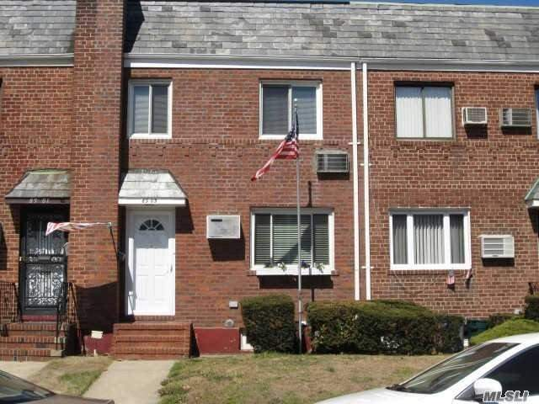
In my rotation, I met with patients with various conditions and problems, but most patients came just for annual wellness check-up, work or school health exam, pre-op clearance, follow up, and medicine refill. Firstly, I learnt how to manage the specific conditions in private clinic setting, including annual wellness check-up, work or school health exam, driver exam, green card exam, pre-op clearance, routine follow up, and medicine refill. Secondly, I learnt how to deal with patients with chronic diseases, such as hypertension, DM, hypercholesterolemia, and BPH, and write related progress notes. Thirdly, I learnt how to determine if the patients have serious conditions to be referred to ER or other specific conditions to be referred to specialists. For example, a young male came with compliant of left testicle pain, and I figured out that he might have testicle torsion. The physician sent him to NYPQ ER for management. The patients in private clinics are different from those to go to hospitals. Most patients are neighbors and the physician is very familiar with them and their families. One patient has been the physician’s patient for more than thirty years. Some patients has visited the clinic since the physician’s father who was also a physician was in this clinic. The physician talked with them about the things happening in their families and their lives. I like the conditions.
In my rotation, I realized more problems. I need more practices and experiences to perform the procedures for some specific patients. For example, for an old African American patient, I could not find the proper blood vessels to draw blood. I will practice on it.

