Int J Surg. 2017 Aug;44:87-93. doi: 10.1016/j.ijsu.2017.06.039. Epub 2017 Jun 16.
Oral versus topical calcium channel blockers for chronic anal fissure-a systematic review and meta-analysis of randomized controlled trials.
Sahebally SM1, Ahmed K2, Cerneveciute R2, Iqbal A3, Walsh SR2, Joyce MR3.
Abstract
BACKGROUND:
Chemical sphincterotomy with pharmacological agents is recommended as first line therapy for chronic anal fissures (CAF). Calcium channel blockers (CCB) are associated with similar efficacy but fewer side effects compared to nitrates. However, the optimal formulation (oral versus topical) is unknown. We aimed to perform a systematic review and meta-analysis to compare the effectiveness of oral and topical CCB in the treatment of CAF.
METHODS:
PubMed and Embase online databases were searched for relevant articles. Two independent reviewers performed methodological assessment and data extraction. Random effects models were used to calculate pooled effect size estimates. A sensitivity analysis was also carried out.
RESULTS:
Four randomized controlled trials describing 279 patients (138 in oral, 141 in topical group) were examined. There was significant heterogeneity among studies. On random effects analysis, topical CCB were associated with a significantly lower rate of unhealed fissure (21.3% vs. 38.4%; OR = 2.65, 95% CI = 1.50 to 4.69, p = 0.0008) when compared to oral therapy. However, there were no significant differences in fissure recurrence (5.4% vs. 5.5%; OR = 1.01, 95% CI = 0.31 to 3.33, p = 0.98) or side effects (15.6% vs. 39.1%; OR = 4.54, 95% CI = 0.46 to 44.3, p = 0.19) between topical and oral CCB. On sensitivity analysis, having excluded the most heavily biased trial, topical CCB were associated with significantly fewer side effects compared to oral therapy (4.3% vs. 38.0%; OR = 13.16, 95% CI = 5.05 to 34.3, p < 0.00001).
CONCLUSIONS:
Topical CCB are associated with better healing and fewer side effects when compared to oral therapy but there is no difference in recurrence rates.

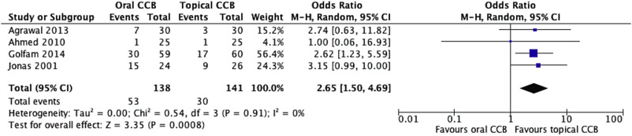
Fig. 2. Meta-analysis of unhealed fissure rates of topical and oral CCB.
All 4 studies reported healing failure rates (n = 279). This was 38.4% in the oral group, compared to 21.3% in the topical group. It shows the topical route to result in better amd the difference was statistically significant (OR = 2.65, 95% CI = 1.50 to 4.69, p = 0.0008; Chi [2] = 0.54 (df = 3), p = 0.91; I2 = 0%)
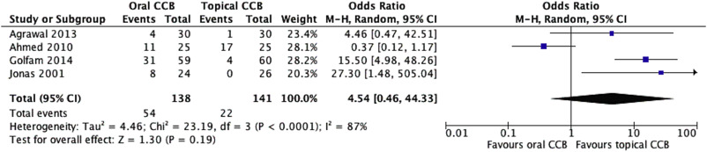
Fig. 3. Meta-analysis of side effects of topical and oral CCB.
All 4 studies reported CCB side effects (n = 279). This was 39.1% in the oral group, compared to 15.6% in the topical group. Although notably higher for oral CCB therapy, on random effects analysis, the difference failed to reach statistical significance (OR = 4.54, 95% CI = 0.46 to 44.3, p = 0.19; Chi [2] = 23.2 (df = 3), p < 0.0001; I2 = 87%). It shows the topical route and oral route have similar side effects.
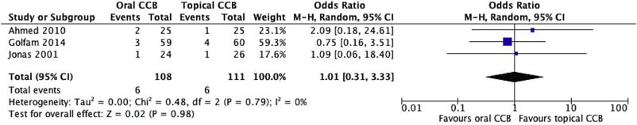
Fig. 4. Meta-analysis of fissure recurrence rates of topical and oral CCB.
Only 3 studies reported fissure recurrence (n = 219). This was 5.5% in the oral group, compared to 5.4% in the topical group. On random effects analysis, the difference was not statistically significant (OR = 1.01, 95% CI = 0.31 to 3.33, p = 0.98; Chi [2] = 0.48 (df = 2), p = 0.79; I2 = 0%). It shows the topical route and oral route have similar recurrence rate.
Combined data from the current meta-analysis demonstrate that topical CCB are associated with significantly better fissure healing compared to oral CCB but that there is no difference in side effects or fissure recurrence between the 2 formulations. It has important clinical significance. Further trials evaluating head-to-head comparisons of oral and topical nifedipine as well as diltiazem with adequate sample sizes and follow up are needed to confirm it.

