WD OB/GYN is my sixth clinical rotation place. I love this rotation because in OB/GYN, I learned many new things from writing specialized progress notes to performing specific procedures. I will greatly benefit from this experience in my future clinical practice.
My working schedule in WD OB/GYN is different every week. My first week was in the clinic for outpatients, working from 9:00 am to 5:00 pm on weekdays. My second week was in OB on-call room from 4:00 pm to 8:00 am on Monday, Wednesday and Friday. My third week was in GYN on-call room from 4:00 pm to 8:00 am on Tuesday, Thursday and Saturday. My fourth week was in GYN on-call room from 8:00 am to 4:00 pm on weekdays. My last week was in the clinic from 9:00 am to 5:00 pm again. In the clinic, I followed the physicians or physician assistants to deal with outpatients, including getting H&Ps, assisting in the test ordering, assessment and managements, and helping in performing procedures, such as IUD placement or bedside ultrasound. During the on-call days and nights, I stayed in the on-call student room or OB triage room. When the physician assistant on duty asked or called, I would go to check up the patients myself or with the PA to collect H&Ps and assist in performing some procedures, such as vaginal delivery. Sometimes, I would go with the PA on duty to ER for consultations. In addition, I could follow the PA on duty to observe or assist in some OB or GYN surgeries, such as C-section or tubal ligation.
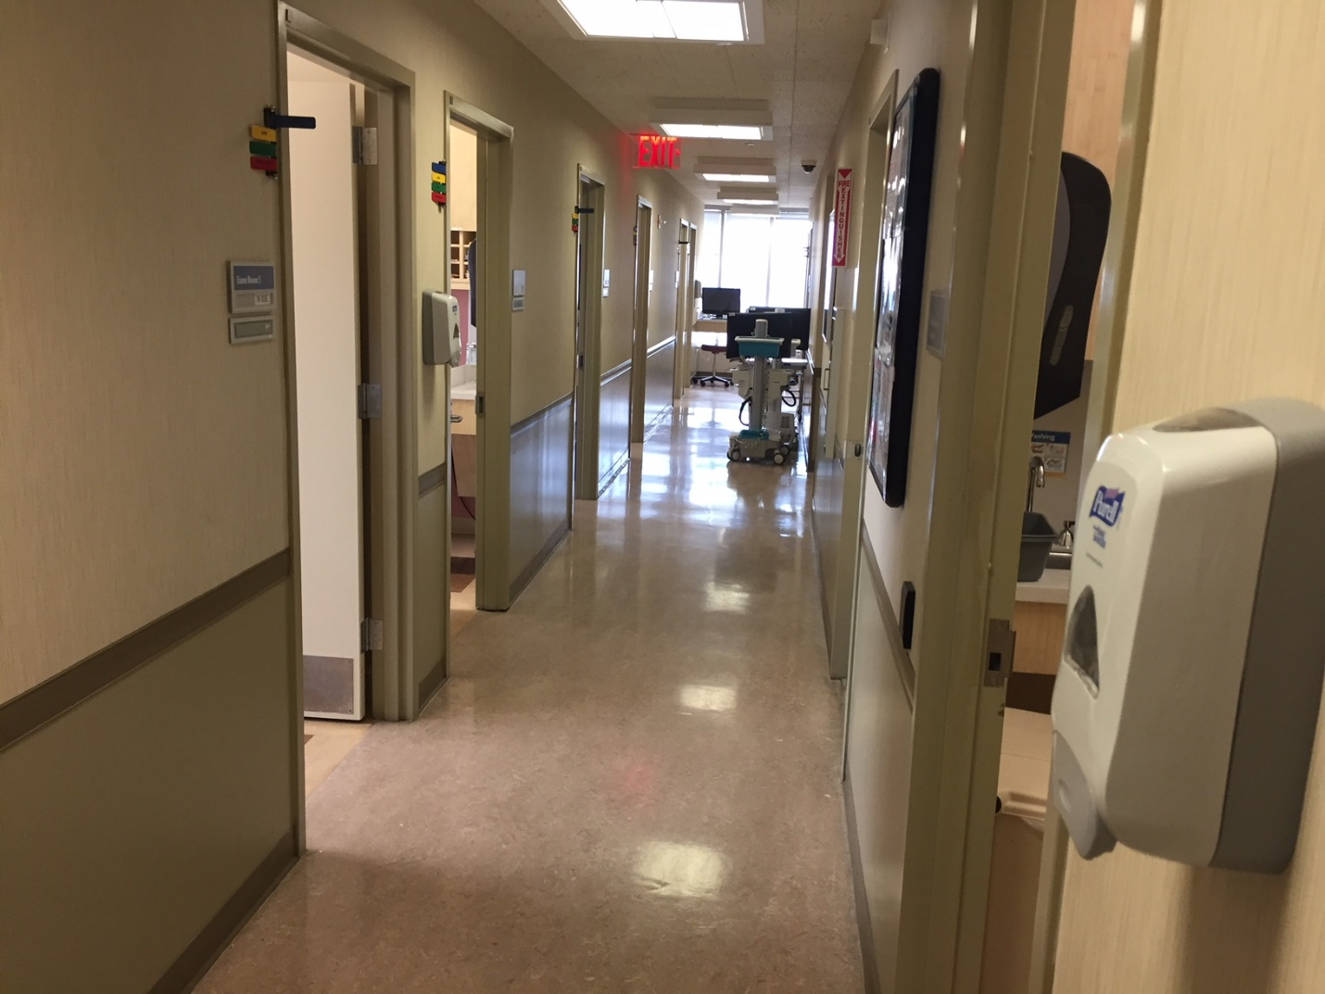
In my rotation, I got the new experiences with OB/GYN patients. I realized that OB/GYN is a very sensitive area, especially for male health care providers. The providers should ask for the permission of patients before any step of care, and for most procedures, a nurse should be there with the provider. Although it is required for any specialty, but it is very strict for OB/GYN. In my rotation, there were many patients who did not want a male watching or helping in some procedures, and I had to wait outside the exam room. Anyway, I learned how to elicit sensitive information during the collection of H&Ps, write the related progress notes, and order the related lab and imaging tests for the patients with different GYN disorders and at different pregnancy states. In addition, I learned how to do some specific procedures, such as C-section, tubal ligation and IUD placement, including their indications, contraindications, steps, possible adverse effects and related managements. During the rotation, I learned how to communicate with the patients about the sensitive information. Since many patients are emotionally unstable during the patient, we need more patience and carefulness. For example, when I called a pregnant patient to see the physician, my pronunciation was wrong even after I asked the nurse because she had a strange name and neither I nor the nurse knew how to spell it. This lady had been waiting for long term and appeared very anxious and angry. She directly complained that I even did not know her name after the long term waiting. I apologized. Afterwards I paid attention to any details to let patients feel comfortable and respected. It is a good experience.
In my rotation, I realized some problems. I need to pay more attention to the situations. For example, when a PS had a busy day, I told her my college required some procedures to be performed in the rotation. She felt that I was aggressive and was not very happy. In the future, I will be careful to avoid any misunderstandings.

