Non-Cardiac Chest Pain.
Frieling T.
Visc Med. 2018 Apr;34(2):92-96. doi: 10.1159/000486440. Epub 2018 Apr 12. Review.
PMID: 29888236

Abstract:
Background:
Non-cardiac chest pain (NCCP) is recurrent angina pectoris-like pain without evidence of coronary heart disease in conventional diagnostic evaluation. The prevalence of NCCP is up to 70% and may be detected (in this order) at all levels of the medical health care system (general practitioner, emergency department, chest pain unit, coronary care). Reduction of quality of life due to NCCP is comparable, and partially even higher, to that caused by cardiac chest pain. Reasons for psychological strain are symptom recurrence in approximately 50%, nonspecific diagnosis with resulting uncertainty, and insufficient integration of other medical disciplines in the diagnostic workup.
Methods and Results:
The management of patients with chest pain has to be multidisciplinary because non-cardiac causes may be frequently encountered. Especially gastroenterological expertise is required since the cause of chest pain is gastroesophageal reflux disease (GERD) in 50-60%, hypercontractile esophageal motility disorders with nutcracker/jackhammer esophagus or diffuse esophageal spasm or achalasia in 15-18%, and other esophageal alterations (e.g., infectious esophageal inflammation, drug-induced ulcers, rings, webs, eosinophilic esophagitis) in 32-35%.
Conclusion:
This review highlights the importance of regular interdisciplinary ward rounds and management of chest pain units.
In this article, causes of non-cardiac chest pain (NCCP) are shown as Gastrointestinal, including Gastroesophageal (GERD), erosive (ERD), non-erosive (NERD) reflux disease, Barrett’s esophagus, Esophageal motility disorder (diffuse esophageal spasm, hypercontractile esophagus, achalasia), Hypersensitive esophagus, Schatzki ring, webs, Eosinophilic esophagitis, Mallory-Weiss syndrome, Boerhaave syndrome, Drug-induced esophageal ulcer, Infections (viral/mycotic esophagitis), Gastroduodenal ulcer, Pancreatitis, biliary colic pain, and cholangitis, Pneumological, including Lung embolism, Pneumonia, Pneumothorax, and Musculoskeletal syndrome (‘chest wall syndrome’), Neurological, including Nerve compression, Zoster infection, and neuralgia, Orthopedic/rheumatologic, including Degenerative spinal disorders, and Rheumatologic disease, and Psychiatric, including Pain disorders, and Depression.
In this article, diagnostic algorithm for the diagnosis of non-cardiac chest pain (NCCP) is set up:
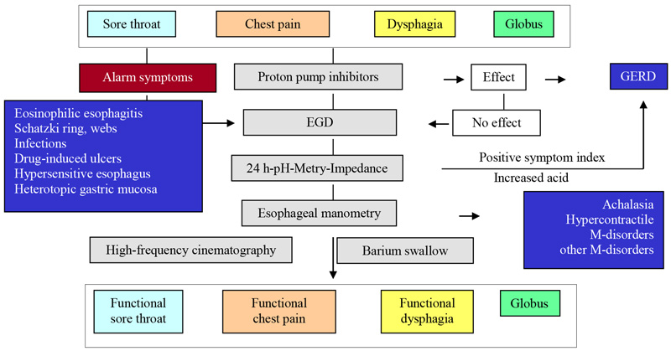
Also, therapeutic options for non-cardiac chest pain (NCCP) are suggested.
It is very useful for our clinical practice for the differential diagnosis and treatment of non-cardiac chest pain.
