Surgery is my first clinical rotation department. In general, it is a learning, interesting, and busy experience for me.
My daily schedule in the surgery department is usually from 5:30 am to 6:00 pm. At 5:30 am in the morning, I arrive at the department, visit my assigned patients and prepare the daily presentation. At 6:00 am, I join in the morning conference of surgery department, and then follow the chief resident with my group in the morning round to present the conditions of my patients. Then I go to my cases in the surgery rooms. Usually, I have two to four cases assigned to me. During the cases, I help to prepare and send the patients, and provide minor assistance in the surgery. At 4pm, I join in the evening round to make presentation and check our patients. Among the cases and rounds, I make my presentations to my supervisor PA or site evaluator, join in the conferences, record my notes and go to ED to visit our new patients.
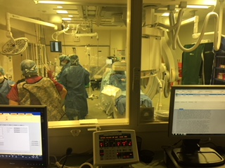
In my rotation, I learnt not only the knowledge about pre-op and post-op care and surgery, but also the friendly and professional attitude. In addition, I realized hard working and studying are necessary for a healthcare provider. The cases in surgery are always interesting. In ENT cases, the surgeons link microscopes to the TV, and I just sit on a chair to watch it. Some surgeons ask a lot of related questions, so I have to prepare for the case and try not to behave like a fool. Some surgeons are excellent teachers, so I prepare my questions to avoid wasting such chances. Some surgeons are active. They listen to songs and even dance. I love them since they make everyone relax. Some surgeons are nervous and serious. In these cases, I try to keep quiet and do not bother them. Sometimes the surgery is relaxing. Time flies by, and to your surprise, the surgery is already done. Sometimes the surgery is stressful. One surgeon was very frustrated to look for parathyroid glands that are not in the normal anatomy. One surgeon tried to find the facial nerve and when he found it under the adenoma, it had already been damaged. Be nice to the nurses, and they could save you. Listen to the orders of your anesthesiologists before you help to clean patients after surgery. Do not do anything without orders if you are not very sure.
In my rotation, I also realized my problems. Firstly, I need to improve my oral English. In addition, I realized that my clinical needs to be improved, too. I will practice more.

